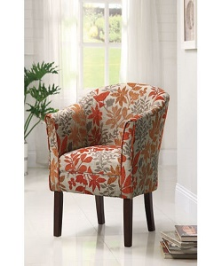

Chair

$26.14

Availability: In stock

Description

Standard Finish in brown wood Available, for all sitting purpose color are available. This furniture must be fixed to the wall with the enclosed wall fastener. Place it in the room and lounge in your home.